LONE BOT (2D PLATFORMER)

A Mini Project Report

submitted in the partial fulfillment of the requirements for

the award of the Degree of

Bachelor of Technology

in

Computer Science and Engineering

by

Vummadi Bhargav Durga Prasad 16761A0559
Ganugapenta Krishna Reddy 16761A0516
Jaliparthi Vijaya 16761A0521
Jakkula Lakshmi Sai Prasanna 17765A0505

Under the guidance of
Mr. Sk. Johny Basha
_{Asst. Professor}

Department of Computer Science and Engineering
Lakireddy Bali Reddy College of Engineering (Autonomous)
Accredited by NAAC & ISO 9001:2015 Certified Institution
Approved by AICTE, New Delhi and Affiliated to JNTUK, Kakinada
2018-2019



Department of Computer Science and Engineering

Certificate

This is to certify that the project entitled “LONE BOT (2D Platformer)” is being submitted by Mr. V. Bhargav Durga Prasad, Mr. G. Krishna Reddy, Ms. J. Vijaya and Ms. J. L. S. Prasanna in partial fulfillment for the award of the Degree of B.Tech in Computer Science and Engineering to the Jawaharlal Nehru Technological University Kakinada, Kakinada. This is a record of bonafide work carried out by him/her under our guidance.
The results embodied in this project report have not been submitted to any other University or Institute for the award of any degree or diploma.

Project Guide Head of the Department
Mr. Sk. Johny Basha Dr. Ch. Venkata Narayana
Assistant Professor Professor

External Examiner

Declaration

The Mini Project work entitled “Lone Bot (2D Platformer)” is a record of bonafide work carried out by us, submitted in partial fulfillment for the award of B.Tech in Computer Science and Engineering to the Jawaharlal Nehru Technological University Kakinada, Kakinada. The results embodied in this project work have not been submitted to any other University or Institute for the award of any degree or diploma.

Name of the Students Signature of the Students
1. V. Bhargav Durga Prasad
2. G. Krishna Reddy
3. J. Vijaya
4. J. Lakshmi Sai Prasanna

ACKNOWLEDGEMENT

The satisfaction that accompanies that the successful completion of any task would be incomplete without the mention of people whose ceaseless cooperation made it possible, whose constant guidance and encouragement crown all efforts with success.
We are grateful to our Mini Project Coordinator Mr. N. V. Naik, Assistant Professor, Computer Science and Engineering for the guidance, inspiration and constructive suggestions that helped us in the preparation of this report.
At the outset, we thank, Dr. Ch. Venkata Narayana, Professor and Head of the Department and Dr. K. Appa Rao, Professor and Principal, for the moral support and the excellent facilities provided.
We wish to express our warm and grateful thanks to our Mini project Guide, Mr. Sk. Johny Basha, Assistant Professor, Computer Science and Engineering for the guidance and assistance he provided in completing our Mini Project successfully.
We thank all our friends who helped us sharing knowledge and by providing material to complete the task in time.

ABSTRACT

The creation of computer games requires a lot of knowledge and experience. Now-a-days, there exists a lot of frameworks that allows developers to create the games in faster and easiest way. This work presents the approach of creating a 2D platformer game with the help of platforms like unity2d, Unreal etc. The basic idea is how to create game level with Tile Map and how to implement physics like jumping, free falling, running and narrating a story along with gameplay. In this process of game making, we come across implementing Artificial intelligence (AI) for the enemies with the help of C# in Unity (Game Engine). This work helps in enhancing Component-Based Development (CBD).

CONTENTS
CONCEPTS Page No
- Introduction 01
- Project Plan 02
2.1 Gaming in the Field of Software Engineering 02
2.2 Background of this Project 02
2.3 About the Project 02
2.4 System Specifications 03
2.4.1 Software Requirements 03
2.4.2 Hardware Requirements 06
- Game Design 07
3.1 Overview of The Project 07
3.1.1 Input Design 07
3.1.2 Objectives 07
3.1.3 Output Design 08
3.2 Components 08
3.3 UML Diagrams 11
- Implementation 14
4.1 Animations 14
4.2 Enemy AI 15
4.3 Audio 16
4.4 Particle System 17
4.5 Coding 18
- Testing 22
  - Overview of Testing 22
- Results 23
- Conclusion 24
- Future Enhancement 25
- References 26

LIST OF FIGURES

CONTENTS Page NO
Figure :1 Unity 05
Figure:2 PhotoShop 05
Figure:3 VisualStudio 06
Figure:4 Controls 07
Figure :5 Output Folder 08
Figure :6 Rigid bodies and Colliders 10
Figure :7 GUI for Enemy 10
Figure :8 GUI for player 11
Figure:9 Use Case 11
Figure:10 Class diagram 12
Figure:11 Sequence diagram for level selection 13
Figure:12 Animations 14
Figure:13 Boar AI 15
Figure:14 Zombie AI 15
Figure:15 UFO AI 16
Figure:16 Partical System 17
Figure:17 Physics material 22

1. Introduction:
A video game is an electronic game that involves interaction with a user interface to generate visual feedback on a two- or three-dimensional video display device such as a TV screen, virtual reality headset or computer monitor. Since the 1980s, video games have become an increasingly important part of the entertainment industry.
A video game, like most other forms of media, may be categorized into genres. Video game genres are used to categorize video games based on their gameplay interaction rather than visual or narrative differences. A video game genre is defined by a set of gameplay challenges and are classified independent of their setting or game-world content, unlike other works of fiction such as films or books. For example, a shooter game is still a shooter game, regardless of whether it takes place in a fantasy world or in outer space. Thus Videogames generate a great essence and thinking out of box for solving strategical problems.

What is a 2D Platformer:
2D platformers, are a variation of platformer games that are a very popular genre of video games. 2D platformers originated in the early 1980s and in the mid 1990 s, platformers made the transition to 3D.
At first, platformers took place on a single screen, where the player would have to overcome certain obstacles. With the advent of Super Mario Bros., the 2D platform games began to introduce scrolling levels, where the players scrolled left to right, with the playable character viewed from a side angle. The character climbs up and down ladders or jumps from platform to platform, fighting enemies, and often has the ability to gain powers or weapons. Later on, the term came to describe games where jumping on platforms, as opposed to shooting, was the main gameplay focus. These include games like Super Mario Bros. and Donkey Kong Country. However, many platform games feature projectile weapons, including the Mario and Castlevania franchises.

2.Project Plan of “Lone Bot”:
This chapter covers the project proposal and feasibility of the proposal along with background study, product and business perspective, the scopes and some preliminary idea of our game.

2.1. Gaming in the Field of Software Engineering:
In the fast-growing field of software engineering and development and even more rapidly growing sector of game development the future is hard to predict. We choose this type of work for doing better with development cycle, development period, graphics, scripting, adopting new technology, animation. In general software project is a project focusing on the creation of software. Consequently, Success can be measured by taking a look at the resulting software. In a game project, the product is a game. But and here comes the point: A game is much more than just its software. It has to provide content to become enjoyable. Just like a web server: without content the server is useless, and the quality cannot be measured. This has an important effect on the game project as a whole. The software part of the project is not the only one, and it must be considered in connection to all other parts: The environment of the game, the story, characters, game plays, the artwork, and so on.

2.2 Background of this Project:
Background is a set of events invented for a plot, presented as preceding and leading up to that plot. It is a literary device of a narrative history all chronologically earlier than the narrative of primary interest. In our project it’s a single player strategy game emphasizing logical thinking and planning. They often stress resource and time management, which usually takes precedence over fast action and character involvement. Tactical organization and execution are necessary, and the game creators usually place the decision-making skills and delivery of commands in the player’s hands.

2.3 About the Project:
It’s a complete strategy game with different levels, where our main character “bot” lost its spaceship and enters into a separate planet where it encounters with a variety of enemies and gathers some keys which help to reach another planets(levels).Finally when it reaches to the final planet it fights against the boss of the planet and gets a key for another spaceship with help of which it can reach its home again.
2.4 System Specifications:
2.4.1 Software Requirements:
Game engine:
A game engine is a software development environment designed for people to build video games. Developers use game engines to construct games for consoles, mobile devices and personal computers. The core functionality typically provided by a game engine includes a rendering engine (“renderer”) for 2D or 3D graphics, a physics engine or collision detection, sound, scripting, animation, artificial intelligence, networking, streaming, memory management, threading, localization support, scene graph and may include video support for cinematics. Implements often economize on the process of game development by reusing/adapting in large part, the same game engine to produce different games or to aid porting games to multiple platforms.

How do they work
A game engine is a framework for game development that supports and brings together several core areas. You can import art and assets, 2D and 3D, from other software, such as Maya or 3s Max or Photoshop; assemble those assets into scenes and environments; add lighting, audio, special effects, physics and animation, interactivity, and gameplay logic; and edit, debug and optimize the content for your target platforms.

Graphics
Modern game engines can power stunning graphics and help facilitate the production, as well as the importing of assets from different platforms, so that you don’t have to wait a lot of time with every import. For most games, game engines can provide you with an architecture with overall high performance rendering capabilities, and with access to fats graphics API, so you can enable the greatest visual fidelity for your games.
Audio
You can choose to design your own sound from scratch, starting with the musical composition, sound effects, voice acting and ending with post-production. You can choose to purchase sound assets from asset-focused platforms, such as the Unity Asset Store, that can be combined and mixed in various ways.

Networking
A lot of players love connecting with their friends over games and apps, whether on PC, console, or mobile. For specific type of games, networking requires a lot server power which can result in a lot of complex workflows and processes. Luckily, a lot of the game engines have workflows, scriptable components, and APIs in place that you can optimize however you want to for online and multiplayer.
Physics
The Physics system in a game engine provide you with the components that handle physical simulation for you. You don’t have to do all the hard coding by yourself, neither code every move created in the scene by the game elements, or collisions between your game components. Game engines enable you to create objects that can behave in a realistic way with just a few lines of code.

Graphical user interfaces(GUI)
Most games have their own GUI that fits the games theme, art direction, and narrative. That’s why a lot of game engines provide creators with tools to build their own graphics user interfaces, such as buttons and drop-down menus, sliders and means of combining different interactable elements.

Scripting
There are a lot of game engines out there that can cater to your needs but if you’re mostly interested in working on a specific genre, whether it’s 2D or 3D or VR/AR, for specific platforms or cross-platform, then you can choose one that’s tailored to your necessities. If you want to build your content once and deploy across multiple platforms, with the Unity game engine you can deploy to over 25 platforms.

Unity(game engine)
Unity gives users the ability to create games and interactive experiences in both 2D and 3D, and the engine offers a primary scripting API in C#, for both the Unity editor in the form of plugins, and games themselves, as well as drag and drop functionality. Prior to C# being the primary programming language used for the engine, it previously supported Boo, which was removed in the Unity 5,release, and a version of JavaScript called Unity Script, which was deprecated in August 2017 after the release of Unity 2017.1 in favor of C#. The engine has support for the following graphics APIs: Direct3D on Windows and Xbox One; OpenGL on Linux, macOS, and Windows; OpenGL ES on Android and iOS; WebGL on the web; and proprietary APIs on the video game consoles. Additionally, Unity supports the low-level APIs Metal on iOS and macOS and Vulkan on Android, Linux, and Windows, as well as Direct3D 12 on Windows and Xbox One.


Fig.1 Unity
Adobe Photoshop CC:
It is used to create some sprite-sheets, which are very helpful for animations and movement of the player. Photo Shop is useful to create some beautiful 2D game art which will attract any player or user. Backgrounds are made with number of sub layers and exported to unity which will give some nice parallax effect.


Fig.2 Photoshop
Microsoft Visual Studio:
We used Visual Studio 2017 for scripting in C# for Unity it is very good at auto-filling and suggesting you with correct methods to use.

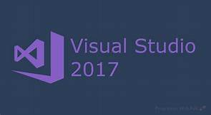

Fig.3 Visual Studio

2.4.2 Hardware Requirements:

For development
OS: Windows 7 SP1+, 8, 10, 64-bit versions only;
macOS 10.11+Server versions of Windows & OS X are not tested.
CPU: SSE2 instruction set support.
GPU: Graphics card with DX10 (shader model 4.0) capabilities.
The rest mostly depends on the complexity of your projects.

For running Unity games
Desktop:
OS: Windows 7 SP1+, macOS 10.11+, Ubuntu 12.04+Graphics card with DX10 (shader model 4.0) capabilities.
CPU: SSE2 instruction set support.

3.Game Design:

3.1. Overview of the project:
The main aim is to provide entertainment to the player and use his problem solving skills to overcome the obstacles and win the game.

3.1.1.Input Design:
The game fallows a basic input system fallowed by many games out there, in addition to that user can use variety of keys as their convenience. The control system is clearly displayed in the main menu →controls.

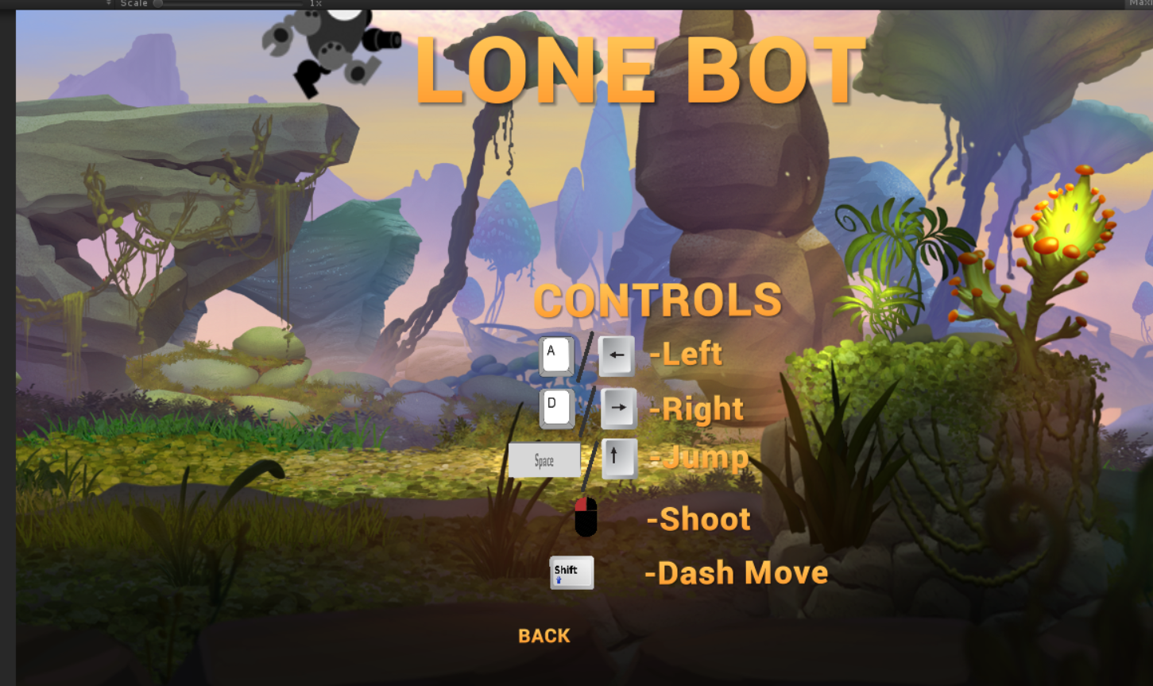

Fig.4 Controls

3.1.2 Objectives:
  - Provide a good gaming experience.
  - Understanding environment of game development
  - Introduction to AI in gaming
  - Improve Component Based Learning.

3.1.3 Output Design:
After designing of the game the output is deployed in such a way that it can be played on cross-platforms like Windows, Mac and Linux.
The output folder consists of fallowing folders with an application and unity crash handler.
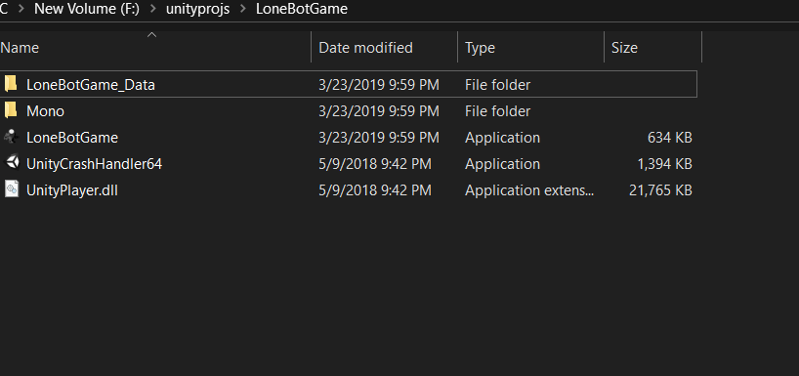

Fig.5 Output folder

3.2.Components:

Rigid body

Rigid bodies enable your game objects to act under the control of physics. The rigid body can receive forces and torque to make your objects move in a realistic way. Any game object must contain a rigid body to be influenced by gravity, act under added forces via scripting, or interact with other objects through the physics engine.

Rigid bodies must be explicitly added to your game object before they will be affected by the physics engine. you can add a rigid body to your selected object from components->Physics->Rigid body in the menu. Now your object is physics-ready, it will fall under gravity and can receive forces via scripting, but you may need a collider or a joint to get it to behave exactly how you want.

When a object is under physics control, it moves semi independently of the way its transform parents move. if you move any parents, they will pull the Rigid body child along with them. however, the Rigid bodies will still fall down due to gravity and react to collision events.

To control your Rigid bodies, you will primarily use scripts to add forces or torque. you do this by calling AddForce() and AddTorque() on the object’s Rigid body. Remember that you shouldn’t be directly altering the object’s Transform when you are using physics.

Colliders

Colliders are another kind of component that must be added alongside the Rigid body in order to allow collisions to occur. If two Rigid bodies bump into each other, the physics engine will not calculate a collision unless both objects also have a collider-less Rigid bodies will simply pass through each other during physics simulation.

Add a Collider with the Component->Physics menu. View the Component Reference page of any individual Collider for more specific information:
- Box Collider- primitive shape of a cube
- Sphere Collider- primitive shape of a sphere
- Capsule Collider- primitive shape of a capsule
- Mesh Collider- creates a collider from the object’s mesh, cannot collide with another Mesh Collider
- Wheel Collider- specifically for creating cars or other moving vehicles
- Terrain Collider- handles collision with Unity’s terrain system

Compound colliders
Compound Colliders are combinations of primitive Colliders, collectively acting as a single Collider. They come in handy when you have a model that would be too complex or costly in terms of performance to simulate exactly, and want to simulate the collision of the shape in an optimal way using simple approximations. To create a Compound Collider, create child objects of your colliding object, then add a Collider component to each child object. This allows you to position, rotate, and scale each Collider easily and independently of one another. You can build your compound collider out of a number of primitive colliders and/or convex mesh colliders.

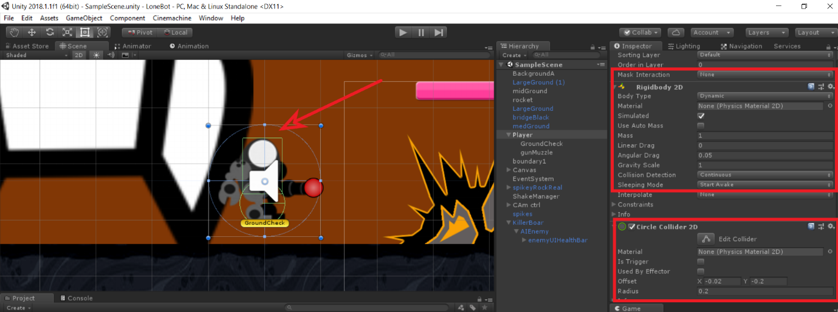

Fig.6 Rigid bodies and colliders

GUI:

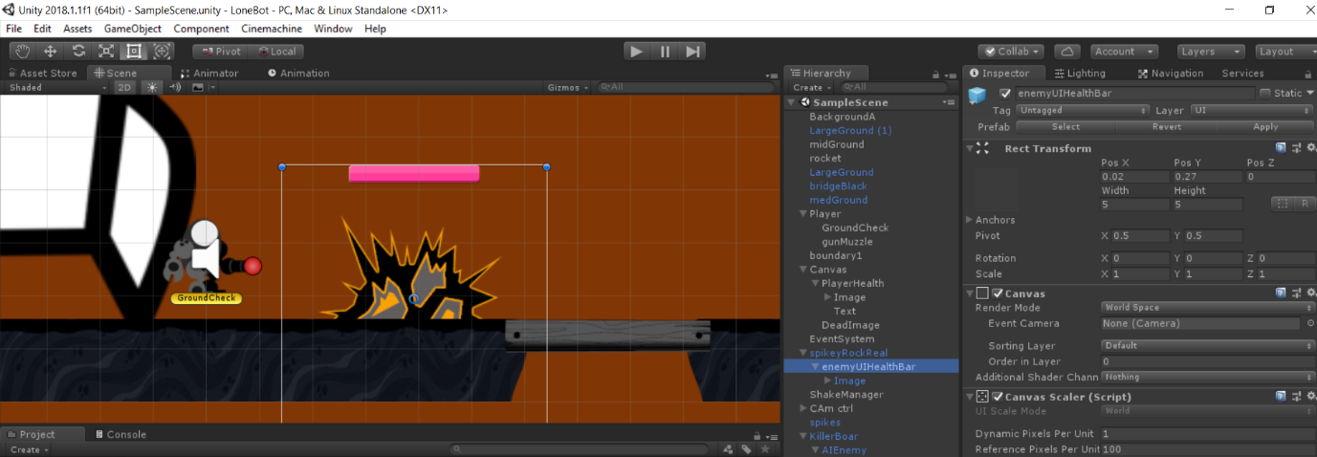
There are many user interactive UI options for the end user in Unity. It provides with number of options like Canvas, panels, images, buttons, sliders etc. These UI helps the player to keep track of his health ,weaponry and coins and many more. Here we have UI for enemies also so that player can keep a track on it.

Fig.7 GUI for Enemy

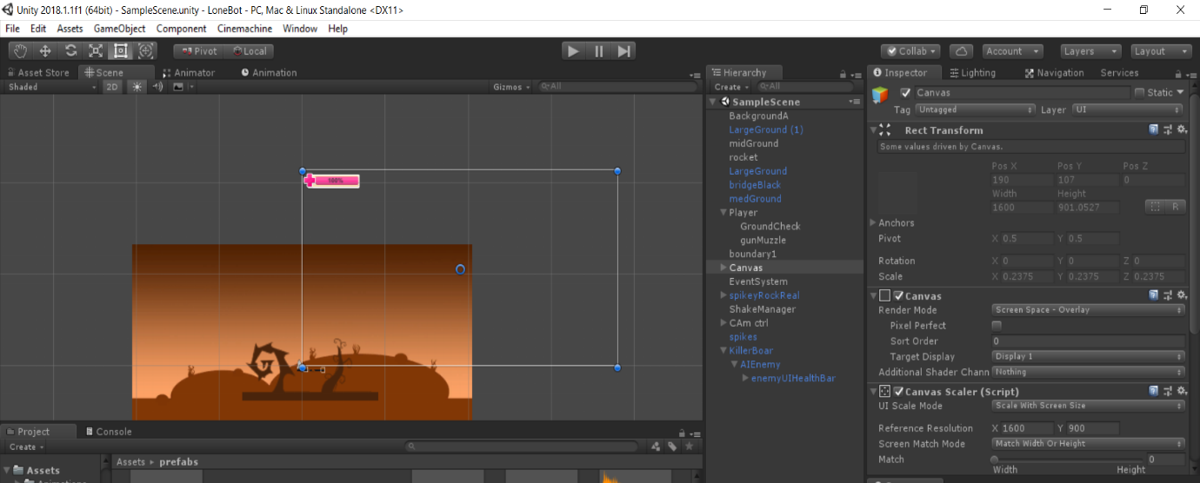

Fig.8 GUI for player

3.3 UML Diagrams:

Use Case:

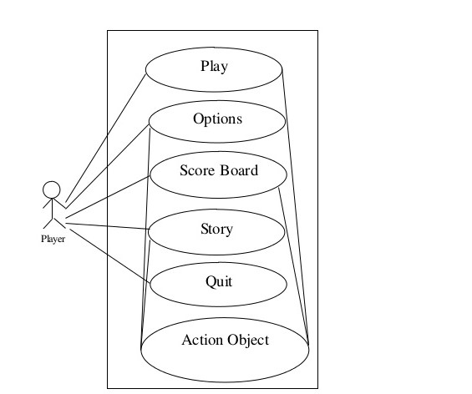
There are many use cases in the project simply we are taking use case of main menu.

.

Fig.9 Use case
Class Diagram:
It is a type of static structure diagram that describes the structure of a system by showing the system's classes, their attributes, operations (or methods), and the relationships among objects.
The classes that involved in our class diagram are as fallows:
- enemyHealth
- PlayerHealth
- PlayerController
- Teleportation
- HealthPickUp
- DoorOpener
- ProjectileCtrl
- RockHit
- Zombie
- RedEnemy
- PatrolEnemyAI
- Enemy Damage
- CamShake

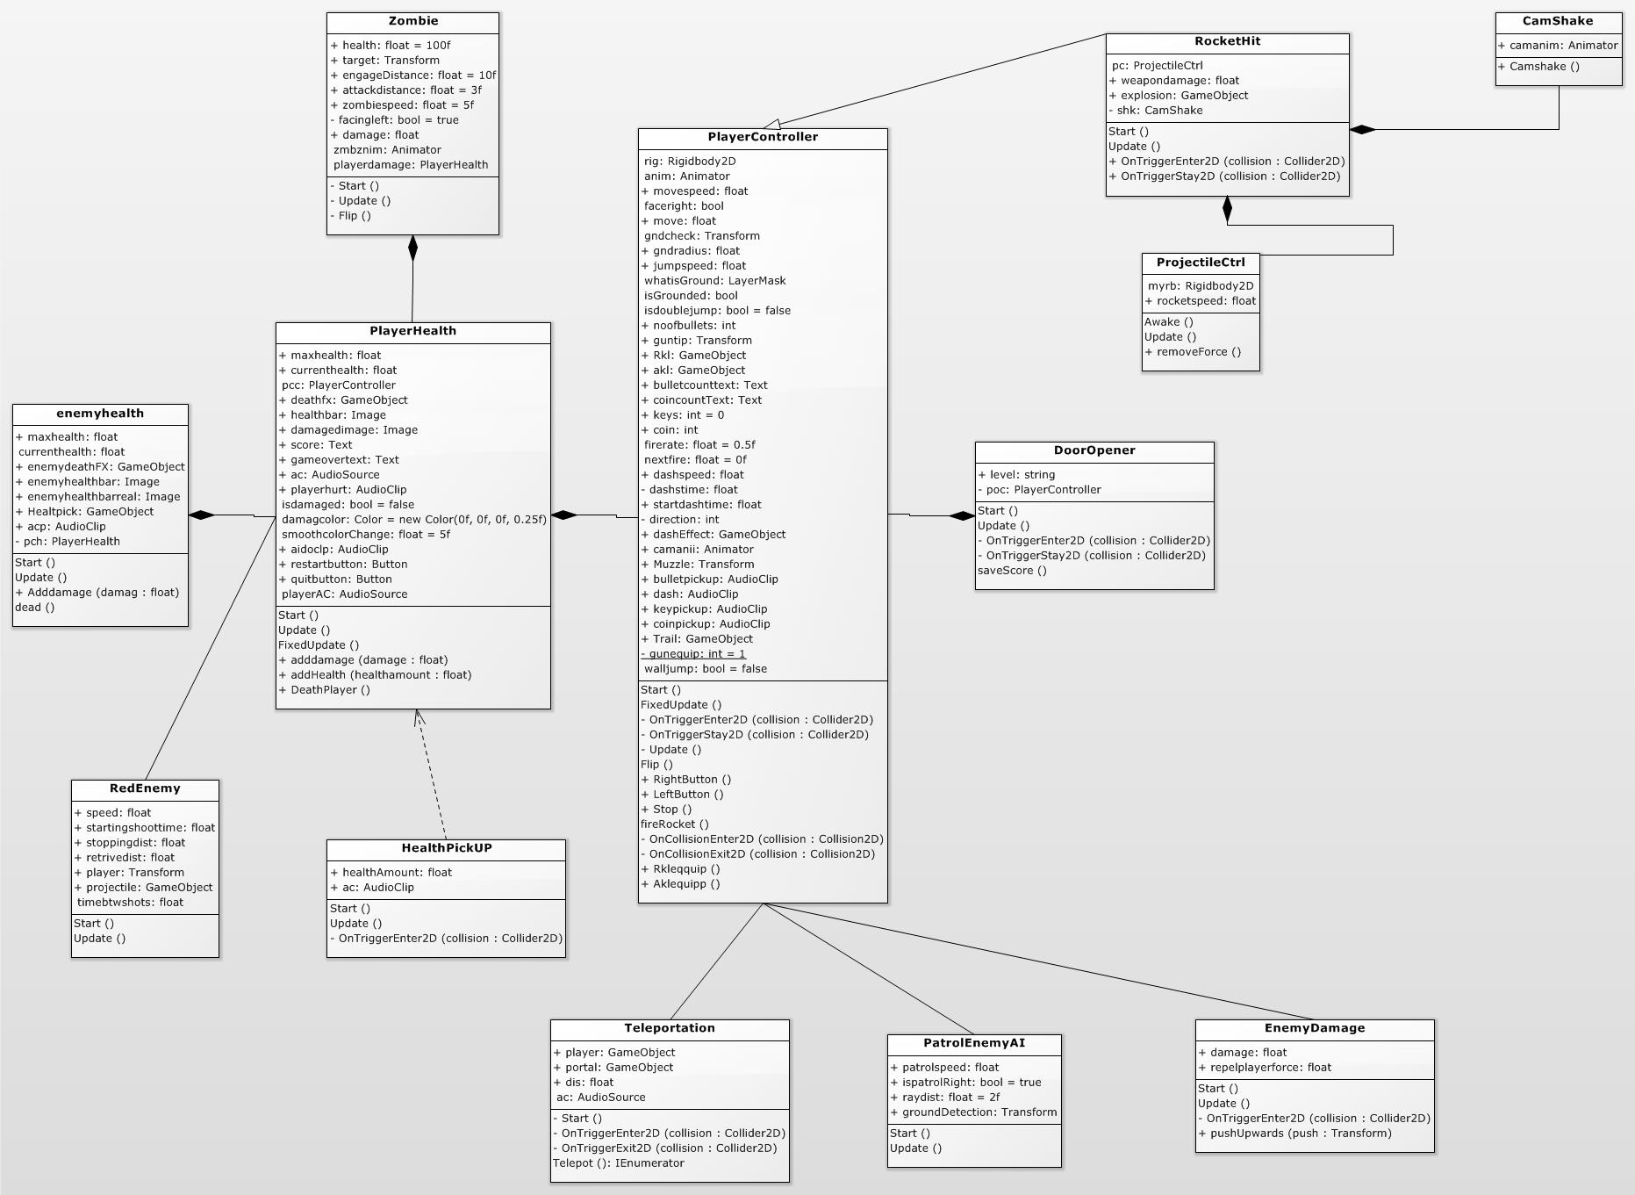

Fig 10 Class diagram

Sequence Diagram:
A sequence diagram shows object interactions arranged in time sequence. It depicts the objects and classes involved in the scenario and the sequence of messages exchanged between the objects needed to carry out the functionality of the scenario. Sequence diagrams are typically associated with use case realizations in the Logical View of the system under development. Sequence diagrams are sometimes called event diagrams or event scenarios.

Here we are simply showing two sequence diagrams that represents selecting a level and also for pausing the game.
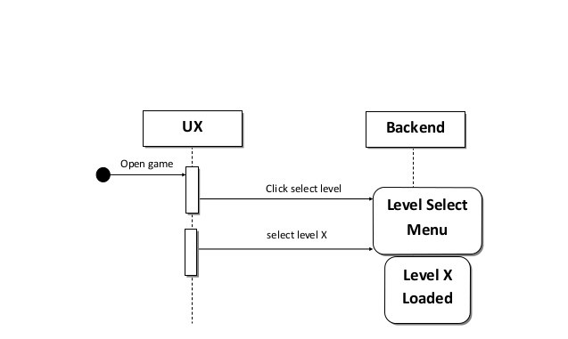

Fig.11 Sequence diagram for level selection

4.Implementation:

4.1. Animations
Here we used sprite sheet animations. Firstly we divided the sprits with help of Unitys Sprite editor after breaking into individual sprites with the help of Animator window animations are made. We adjusted frames and sprites to get the required animation.
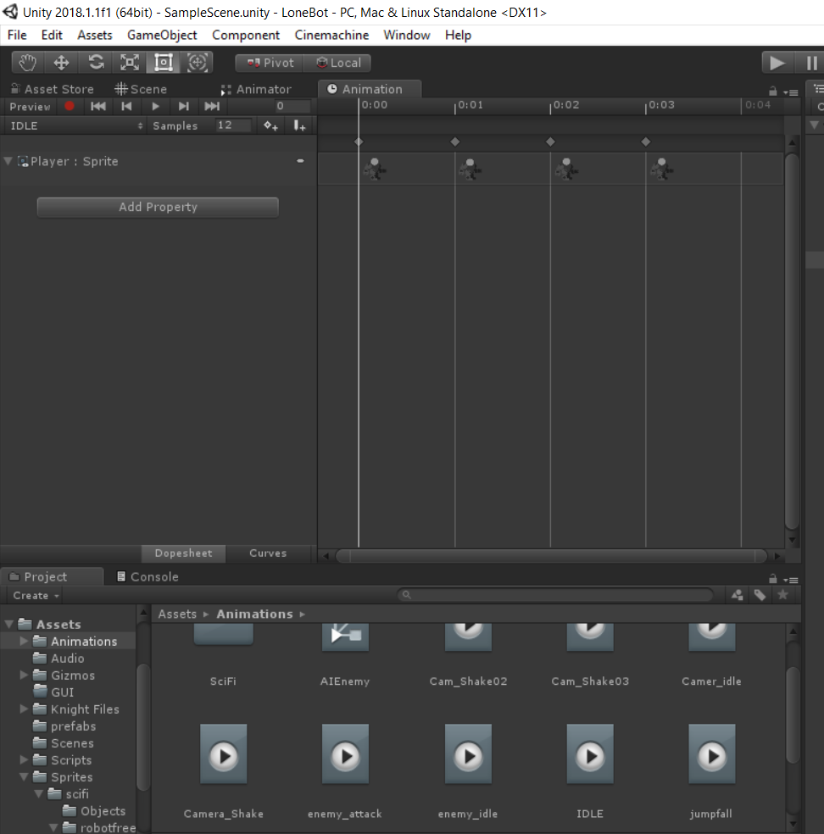
Fig.12 Animations

4.2 Enemy AI
There are mainly 3 kinds of enemy and a boss in the game.3 different kinds of AI systems are implemented here. For the first enemy i.e, killer boar it has a particular trigger area if the player enters into its area it will start attacking. If player leaves it stops attacking and remains idle.
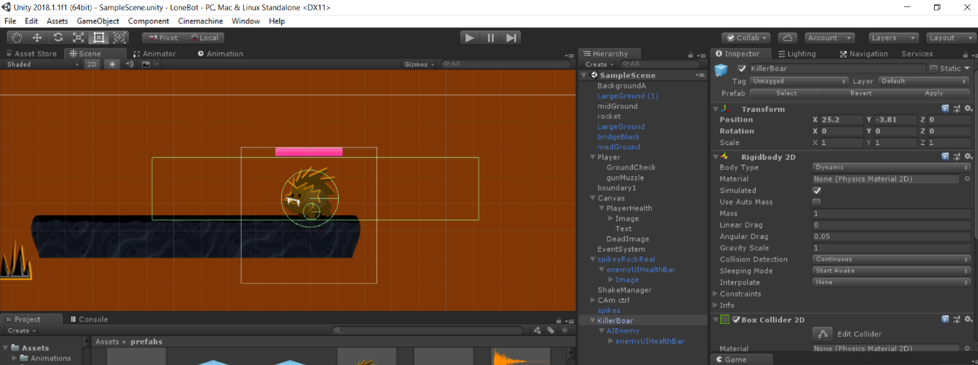
Fig.13 Boar AI
The second type of enemy uses ray casts of Unity to find player. If player is at certain distance enemy starts fallowing if player is close enough it starts attacking the player. If player is out of range it remains idle.

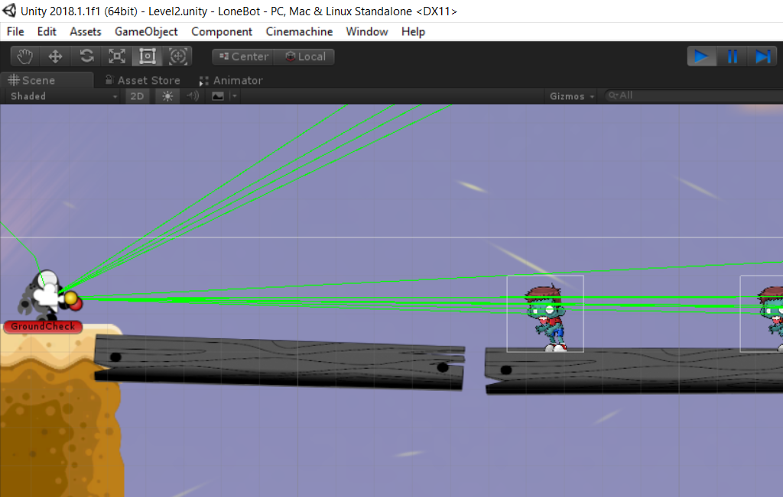
Fig.14 Zombie AI

For third type of enemy we implemented A* algorithm with help of unity package for finding the shortest path to reach the player over a certain area in the game.
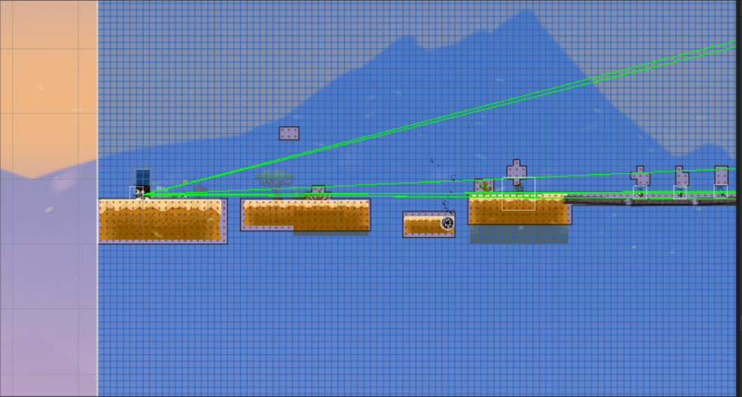
Fig.15 UFO AI

4.3.Audio:
Audio Source
The Audio source plays back an audio clip in the scene. The clip can be played to an audio listener or through an audio mixer . the audio source can play any type of Audio clip and can be configured to play these as 2D,3D or as a mixture. The audio can be spread out between speakers and morphed between 3D and 2D.This can be controlled over distance with falloff curves. Also, if the listener is within one or multiple Reverb Zones, reverberation is applied to the source. Individual filters can be applied to each audio source for an even richer audio experience.
Creating Audio Sources
Audio Sources don’t do anything without an assigned Audio Clip. The Clip is the actual sound file that will be played back. The Source is like a controller for starting and stopping playback of that clip, and modifying other audio properties.

To create a new Audio Source:
  - Import your audio files into your Unity Project. These are now Audio Clips.
  - Go to Game Object->Create Empty from the menubar.
  - With the new Game Object selected, select Component->Audio->Audio Source.
  - Assign the Audio Clip property of the Audio Source Component in the Inspector.
If you want to create an audio source just for one audio clip that you have in the assets folder then you can just drag that clip to the scene view-a Game object with an Audio Source component will be created automatically for it. Dragging a clip onto on existing Game object will attach the clip along with a new audio source if there isn’t obe already there. If the object does already have an Audio Source then the newly dragged clip will replace the one that the source currently uses.
4.4 Particle System
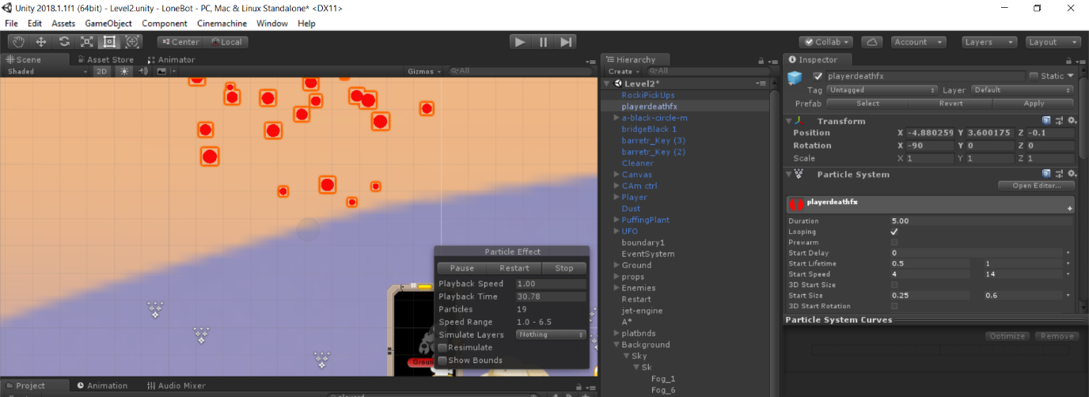
The particle system in unity is very helpful for making effects like making blood splash, rockets fling, water effects and many more. In order to use partical system of unity we should make material for the system and add the image as albideo and make it as particles and then softing. Add it to the renderer component of the particle system and adjust some values to get the exact effect.
Fig.16 Particle system

4.5 Coding
There are number of scripts(Programs) involved in the game. Among them the here is boss script that plays a key role. Here is a snapshot of the code.
using System.Collections;
using System.Collections.Generic;
using UnityEngine;
using UnityEngine.UI;

public class Boss : MonoBehaviour {

public int damage;
private float timeBtwDamage = 1.5f;

public GameObject Bossdeathfx;
public Animator camAnim;

private Animator anim;
public bool isDead;
public float maxhealth;
float currenthealth;

public Image enemyhealthbar, enemyhealthbarreal;
public GameObject Healtpick;
public AudioClip acp;
private PlayerHealth pch;

private void Start()
{
anim = GetComponent<Animator>();
currenthealth = maxhealth;
enemyhealthbar.fillAmount = maxhealth;
enemyhealthbarreal.gameObject.SetActive(true);
pch = FindObjectOfType<PlayerHealth>();

}

private void Update()
{

if (currenthealth <= 25) {
anim.SetTrigger("stageTwo");
}

if (currenthealth <= 0) {
anim.SetTrigger("death");

}

// give the player some time to recover before taking more damage !
if (timeBtwDamage > 0) {
timeBtwDamage -= Time.deltaTime;
}

enemyhealthbar.fillAmount = currenthealth / maxhealth;
}
public void Bossdamage(float damag)
{
enemyhealthbarreal.gameObject.SetActive(true);
currenthealth -= damag;
if (currenthealth <= 0)
{
enemyhealthbar.fillAmount = 0f;
AudioSource.PlayClipAtPoint(acp, transform.position);
Instantiate(Bossdeathfx, transform.position, Quaternion.identity);
Instantiate(Healtpick, transform.position, transform.rotation);
Destroy(gameObject);

}
}

private void OnTriggerEnter2D(Collider2D other)
{
// deal the player damage !
if (other.CompareTag("Player") && isDead == false) {
if (timeBtwDamage <= 0) {
camAnim.SetTrigger("shake");
PlayerHealth playerdamage = other.gameObject.GetComponent<PlayerHealth>();
playerdamage.adddamage(damage);
}
}
}
}

5.Testing:
5.1 Overview of Testing
In the field of game development there should be continuous testing of the game and finding bugs and error fixing. We tested our game thoroughly and fixed as many bugs as possible. For example in starting days of development we had a bug that when player character jumps and try’s to land on another platform it keeps stuck to the platforms this bug is fixed by adding some Physics material to the player.
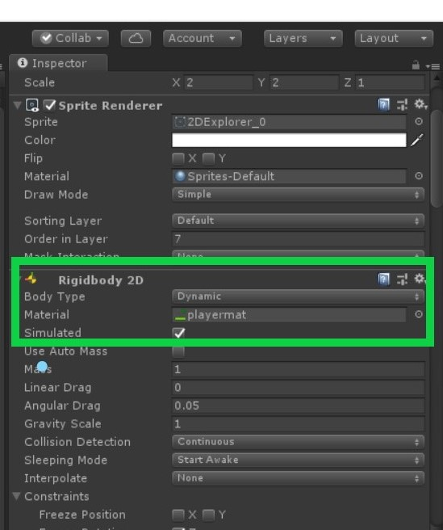

Fig.17 physics material

6.Results:
The results of testing helped us a lot to fix our game and made the game so smooth and controls are so easy to play. But more number of bugs may arise as players play the game. We support the comments of our players and fix those bugs.

7.Conclusion:
We here by conclude that completed a beautiful strategical 2D platformer with three levels and a boss fight , and finally a cutscene is added. Our team has gone through a lot of effort while making this game. We used many components of the Unity like colliders, audios, rigid bodies, effectors etc.

8.Future Enhancement
- Making the game available for android users
- Adding more levels
- Adding more powerups
- Including new enemies with different AI
- More strategical traps

9.References
- https://www.youtube.com/watch?v=gC0N6ETulv0&list=PL2cNFQAw_ndyKRiobQ2WqVBBBSbAYBobf
- https://www.youtube.com/watch?v=zc8ac_qUXQY&t=57s
- https://www.youtube.com/watch?v=cXefXSD2SM0&t=101s
- https://docs.unity3d.com/Manual/index.html
- https://docs.unity3d.com/ScriptReference/index.html
- https://www.youtube.com/watch?v=Pv1Bi6ao_J87.
- Mastering Unity Scripting by Alan Thorn

